Like a sycamore leaf – what happens when it all goes quiet in a helicopter.
I am a humble PPL(H), so in the world of helicopters, I am the bottom. In civilian life however, a helicopter pilot is quite a cool thing. I can’t recall the number of people who, when they find out I am a helicopter pilot, have said ‘You wouldn’t get me in one of those things... engine quits and that’s it’. I of course explain otherwise. Let me try to do the same here, to an audience who will at least understand aerodynamics.

Drag and lift
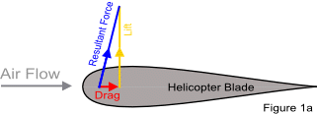
If you hold any object out of a moving car window, it will be dragged backwards (drag). If the object happens to be a wing (or helicopter rotor blade), then it will also lift upwards at quite a rate (lift).The resultant force will be upwards and slightly backwards. Let’s say 10 degrees past vertical, so 100 degrees to the airflow (Fig. 1a).
When a helicopter blade is driven through the air, it is this force that makes the blade lift. The blade in turn lifts the helicopter. The backwards force (drag) is cancelled out by the engine driving the blade forwards. If it were not for the engine, the blade would slow down.

What drives the blades if not the engine?
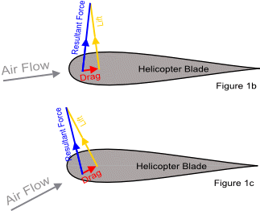
Now let’s imagine that the helicopter is descending. In this state, as well as the airflow created by the blade moving forwards, there is an upwards airflow caused by the helicopter descending. This means that the airflow that the blade feels will be slightly upwards from where it was. This in turn will mean that the resultant force that was 10 degrees to vertical is now less than that, let’s say 5 degrees (Fig. 1b). The actual angle will depend on how quickly the helicopter is falling compared to the forward speed of the blade. As the helicopter descends more quickly or the blade slows down the resultant force (movement) will become closer to vertical. If the blade is slow enough, or the helicopter descends quickly enough, we can even make that angle go past vertical and it starts pointing forwards (Fig. 1c).

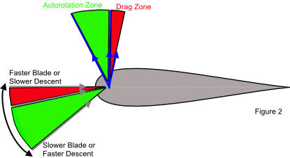
When this is the case and the force points forwards of vertical we can say that the force is in the autorotation zone. At this point, the airflow itself will drive the blade forwards and the engine is not needed. The more the airflow points upwards, the further forwards the resultant force will point. The air flow will point more in an upwards direction, the slower the blade rotates or the faster the helicopter descends (Fig. 2).

So how does this help?
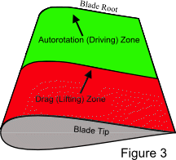
So let’s say you are flying along and the engine quits. You flatten out the blades by dropping the collective lever. At this point the helicopter starts to descend, there is an updraft, and the angle of the resultant force acting on the blade we spoke of, starts to move forwards, until it starts driving the blades around.
Now the tip of the blade will be going faster through the air than the end nearest the centre (the root). This means that the root of the blade will start driving the blade before the tip does because the slower the forward movement, the further forward the force will point (Fig. 3).
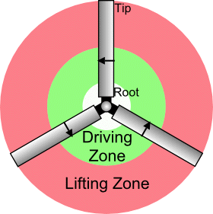
This driving force will spread along the blade towards the tip as the helicopter increases its descent. As more of the blade is subjected to this driving force, the blade will speed up and generate more lift until the helicopter settles into a steady descent where the slower parts of the blades drive them around and the faster parts generate lift (Fig.4). This is the point at which the helicopter will be descending in a controlled manner, and you will have time to pick your landing site and aim for it. This state is called autorotation.
When you reach your desired landing spot, you pull back on the cyclic stick to flare the helicopter. Just like a fixed wing aircraft, flaring the helicopter will trade forward speed for lift so your descent will slow right down without slowing down the blades. As you come to a stop just above the ground, you cushion your contact with the ground by lifting the collective lever, which angles the blades upwards and gives us the lift back, as if we were flying with an engine.
Author: Steve James Helimove limited www.helimove.co.uk 2012

